**Problem : Minimum Distance**

Two riders A and B are travelling on a highway towards each other on two roads that intersect at right angle at speeds **VA**meters/second and **VB** meters/second. A is at a distance of **'x'** meters and B is at a distance of **'y'** meters from the intersection. Calculate the minimum distance between these two riders that is possible.  
  
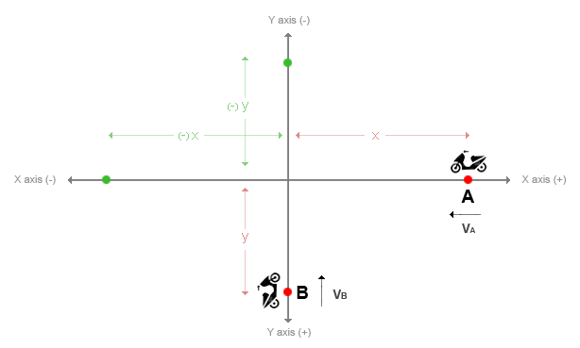  
                                                             **Fig:Approaching Intersection**

**Input Format:**  
  
First line contains the distance of Rider A from intersection denoted by x  
Second line contains the distance of Rider B from intersection denoted by y  
Third line contains the Velocity of Rider A denoted by VA  
Fourth line contains the Velocity of Rider B denoted by VB

**Output Format:**  
  
Print the minimum distance between these two riders, if minimum distance is non-zero. If minimum distance is zero, print it as 0.0

**Constraints:**

**x > 0**

**y > 0**

**VA > 0**

**VB > 0**

**Calculation and printing of output should be done upto 11-precision**

[**Sample Input and Output**](https://www.blogger.com/null)

|  |  |  |
| --- | --- | --- |
| **SNo.** | **Input** | **Output** |
| 1 | 100 100 10 10 | 0.0 |
| 2 | 500 300 20 14 | 41.18252056395 |
| 3 | 100 100 30 40 | 22.36067977500 |
| 5 | 0 50 -20 30 | Invalid Input |